Embedded System

An **embedded system** is a computer **system** with a dedicated function within a larger mechanical or electrical **system**, often with real-time computing constraints. It is **embedded** as part of a complete device often including hardware and mechanical parts.**Embedded systems** control many devices in common use today.

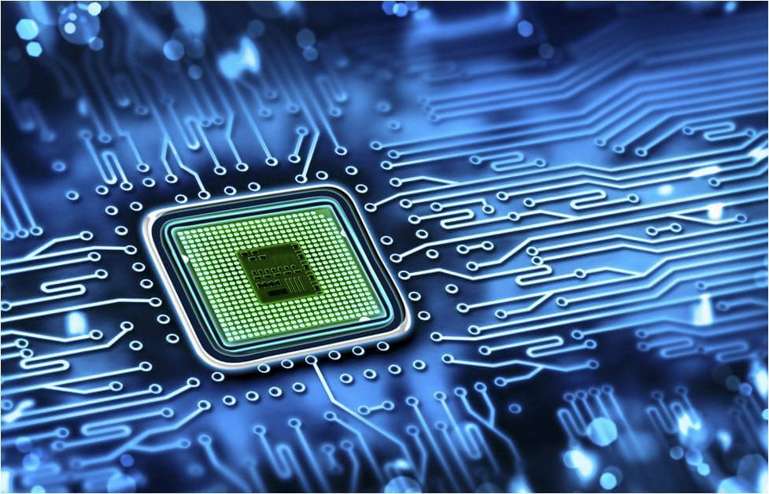

Parts of embedded systems

1. Microcontroller or microprocessor
2. Peripherals (external i/o, communication, sensors)
3. Clock
4. Power
5. Memory

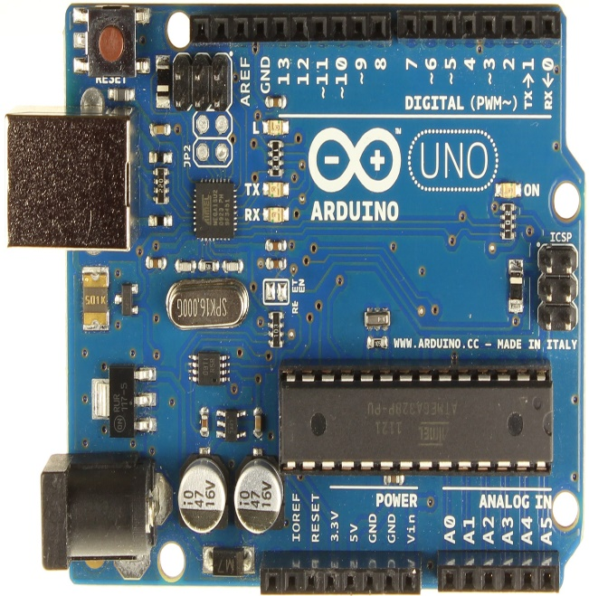 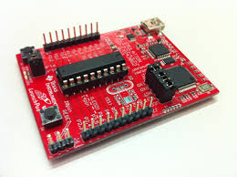

Applications

1. Car System

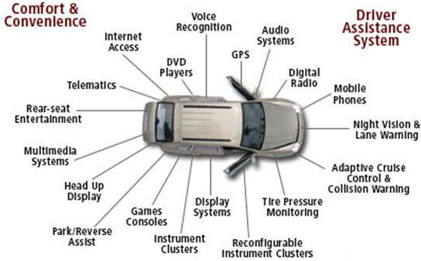

1. Robotics

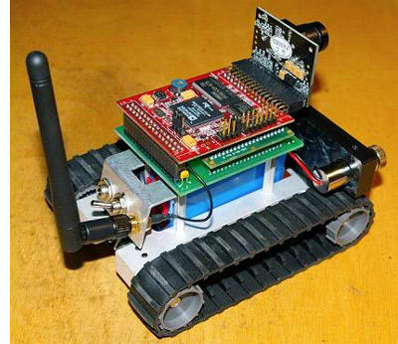

1. Home Automation

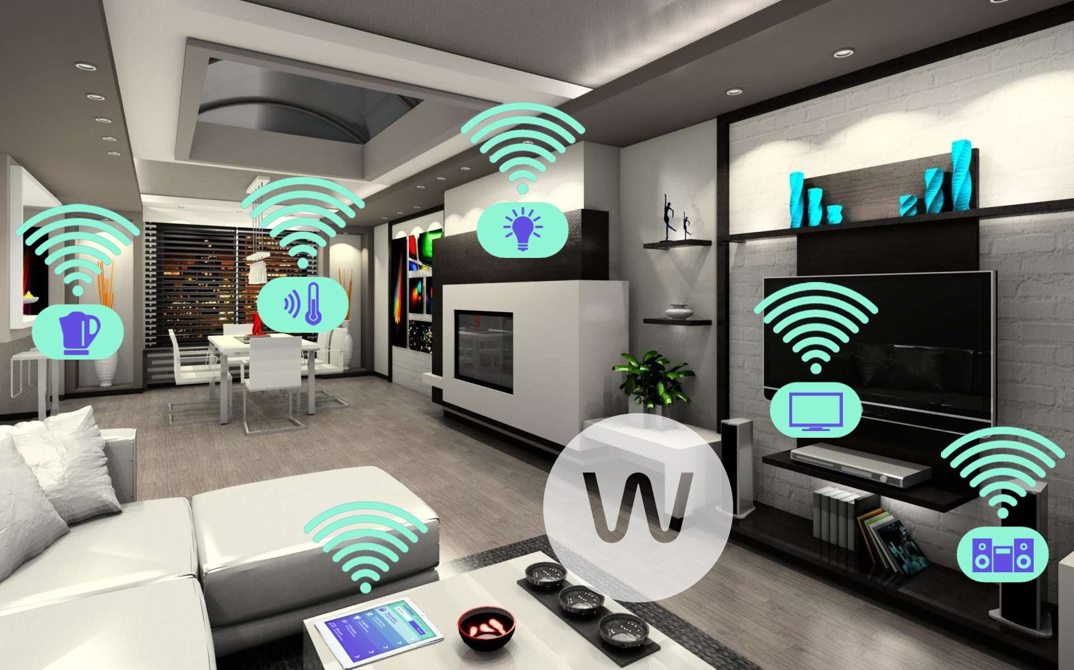

1. Wearable Technology

